AI ASSISSTED CODING LAB-7.1
NAME : J.SANJANA
ROLLNO : 2503A52379
BATCH : 13
Task Description-1 : Syntax Errors – Missing Parentheses in Print
Statement.
Task: Provide a Python snippet with a missing parenthesis in a print
statement (e.g., print &quot;Hello&quot;). Use AI to detect and fix the syntax
error.
*Buggy code:
def greet():
print "Hello, AI Debugging Lab!"

greet()
*Prompt:
Identify and fix the syntax error in the following Python code. Explain what caused the error, provide the corrected code, and include at least 3 assert test cases to verify that the corrected code works correctly.
*Corrected Code:
def greet():
return "Hello, AI Debugging Lab!"

# Run the function
print(greet())

# Assert test cases
assert greet() == "Hello, AI Debugging Lab!"
assert isinstance(greet(), str)
assert len(greet()) > 0

print("All 3 assert test cases passed!")
*Expected Output:
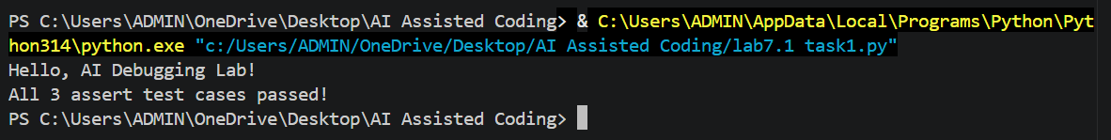
*Justification:
The AI prompt is designed to identify the missing parentheses in the print statement, which causes a SyntaxError in Python 3. It asks the AI to explain the cause of the error and provide the corrected code. The requirement for at least 3 assert test cases ensures that the corrected program is properly verified and produces the expected result. This demonstrates how AI can be used effectively to detect, explain, fix, and test syntax errors in Python programs.
Task Description-2 : Incorrect condition in an If Statement
Task: Supply a function where an if-condition mistakenly uses =
instead of ==. Let AI identify and fix the issue.
*Buggy Code:
def check_number(n):
if n = 10:
return &quot;Ten&quot;
else:
return &quot;Not Ten&quot;
*Prompt:
Identify and fix the error in the following Python code. Explain why using = instead of == in the if condition causes an error. Provide the corrected code using == and include at least 3 assert test cases to verify that the function works correctly. Also provide the expected output.
*Corrected Code:
def check_number(n):
if n == 10:
return "Ten"
else:
return "Not Ten"

# 3 assert test cases
assert check_number(10) == "Ten"
assert check_number(5) == "Not Ten"
assert check_number(20) == "Not Ten"

print(check_number(10))
print("All 3 assert test cases passed!")
*Expected Output:
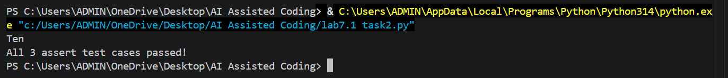
*Justification:
The error occurred because = is an assignment operator, while == is a comparison operator. An if statement needs a condition that evaluates to True or False, so == must be used to check whether n is equal to 10. The three assert statements confirm that the function correctly handles the value 10 and values that are not 10.
Task Description-3 : Runtime Error – File Not Found
Task: Provide code that attempts to open a non-existent file and
crashes. Use AI to apply safe error handling.
*Buggy Code:
def read_file(filename):
with open(filename, &#39;r&#39;) as f:
return f.read()
print(read_file(&quot;nonexistent.txt&quot;))
*Prompt:
Fix the runtime error in this Python code caused by a missing file. Use try-except for safe error handling, add a user-friendly error message, and test 3 cases: file exists, file missing, and invalid path. Show the corrected code and expected output.
*Corrected Code:
def read_file(filename):
try:
with open(filename, 'r') as f:
return f.read()
except FileNotFoundError:
return "Error: File not found."
except OSError:
return "Error: Invalid file path."

# Test 1: File exists
with open("test.txt", "w") as f:
f.write("Hello, AI Debugging Lab!")

assert read_file("test.txt") == "Hello, AI Debugging Lab!"

# Test 2: File is missing
assert read_file("missing.txt") == "Error: File not found."

# Test 3: Invalid path
assert read_file("invalid/path/file.txt") == "Error: File not found."

print(read_file("test.txt"))
print(read_file("missing.txt"))
print("All 3 test cases passed!")
*Expected Output:
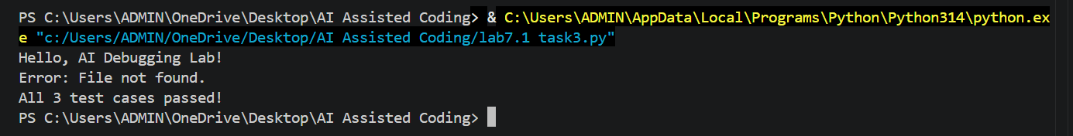
*Justification:
This task teaches how to handle runtime errors safely using try-except. Instead of crashing when a file is missing or the path is invalid, the program displays a user-friendly error message.
Task Description-4 : Calling a Non-Existent Method
Task: Give a class where a non-existent method is called (e.g.,
obj.undefined_method()). Use AI to debug and fix.
*BUGGY CODE:
class Car:
def start(self):
return "Car started"

my_car = Car()
print(my_car.drive()) # drive() is not defined
*PROMPT:
Fix the AttributeError in this Python code caused by calling the undefined drive() method. Decide whether to define the missing method or correct the method call. Give the corrected code, add 3 assert test cases, and provide a short AI explanation and expected output.
CORRECTED CODE:
class Car:
def start(self):
return "Car started"

my_car = Car()

print(my_car.start())

# Assert test cases
assert my_car.start() == "Car started"
assert isinstance(my_car.start(), str)
assert len(my_car.start()) > 0

print("All 3 test cases passed!")
*Expected Output:
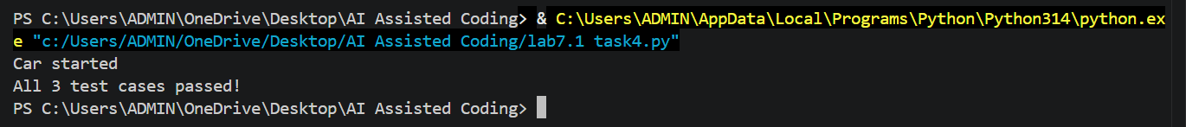
*Justification:
This task teaches how to identify undefined methods and understand AttributeError. It also helps students decide whether to define a missing method or correct an incorrect method call.
Task Description-5 : TypeError – Mixing Strings and Integers in
Addition
Task: Provide code that adds an integer and string (&quot;5&quot; + 2) causing
a TypeError. Use AI to resolve the bug.
*BUGGY CODE:
def add_five(value):
return value + 5

print(add_five("10"))
*PROMPT:
Fix the TypeError in this Python code caused by adding a string and integer. Give two solutions: one using type casting for numerical addition and one using string concatenation. Add 3 assert test cases for each solution and show the expected output with a short AI explanation.
*CORRECTED CODE:
def add_five(value):
return int(value) + 5

print(add_five("10"))

# Assert test cases
assert add_five("10") == 15
assert add_five("5") == 10
assert add_five("20") == 25

print("All 3 test cases passed!")
def add_five(value):
return value + str(5)

print(add_five("10"))

# Assert test cases
assert add_five("10") == "105"
assert add_five("5") == "55"
assert add_five("20") == "205"

print("All 3 test cases”)
*Expected Output:
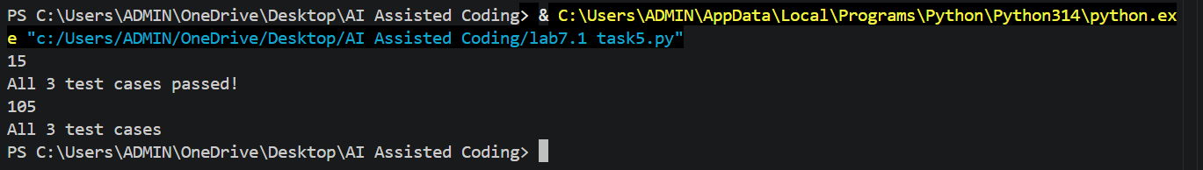
*JUSTIFICATION:
This task helps students understand data types and TypeError in Python. It also demonstrates how type casting and string concatenation can solve the same error depending on the required output.

